2019 SSIR Queen Contest Horsemanship
Pattern has a possible 50-point score per judge
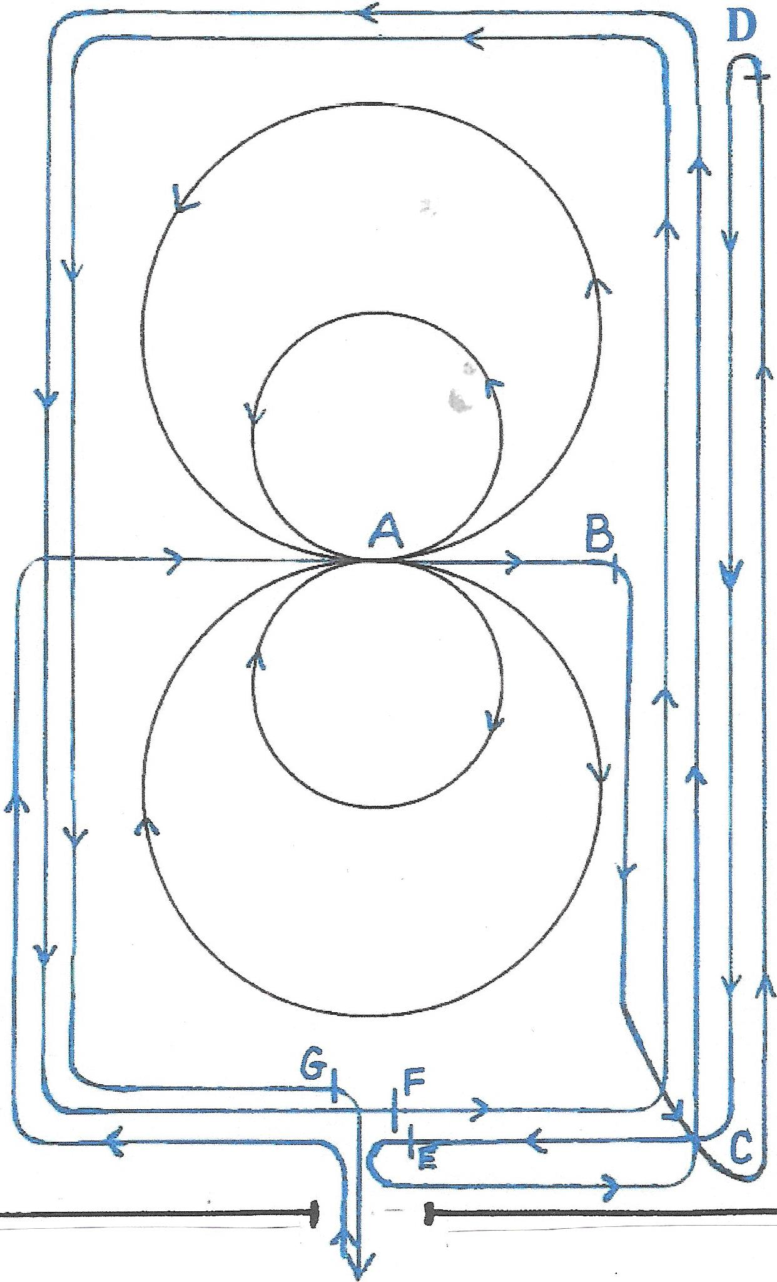
Enter the arena and walk to Position A. Begin figure 8 work to the right at a fast lope and make the larger figure 8. Reduce speed and go into smaller figure 8. Stop at Position B. Trot to Position C. Begin fast pace at Position C, coming to a stop at position D. Turn away from fence at Position D and proceed to the Exit gate at a fast pace doing a presentation ride. Stop at gate. Make a 180 degree turn to the left (towards gate) at Position E. Take flag from contest personnel and circle the arena once at a speed of the contestant’s choice. Stop at the gate and hand flag to contest personnel at Position F. Make a second circle around arena as a presentation ride. Come to a stop at the gate at Position G and exit the arena.
The Horsemanship portion of the SSIR Queen contest is to demonstrate the ability of the contestant to show herself and her horsemanship skills. Therefore, the SSIR has adopted the following pattern to demonstrate basic horsemanship skills such as controlling speed, increasing speed, picking up correct leads, displaying a flag while presenting herself in a manner that demonstrates the poise and elegance associated with the title of “Queen”. In an effort to eliminate the need for a finished reining horse, judges will be critiquing basic horsemanship skills, appearance and presentation while correctly performing the adopted pattern.

